**Name:** Hithesh Shanmugam

**Student ID:** 2068266

**Course:** CSC-578 Neural Networks and deep learning

**Assignment-3**

1. **Whether output was matched:**

The third cell were training the network with 3 epochs with minibatch of size 8 and eta of 1.5 with no test set I got the same results as in the html file. The results were same.

1. **Whether output was matched:**

The fourth cell were training the network with 100 epochs with minibatch of size 8 and eta of 1.5 with test set I got the same results as in the html file. The results were same.

1. **Whether output was matched:**

The fifth cell were training the network with 100 epochs with minibatch of size 8 and eta of 0.7 with test set I got the same results as in the html file. The results were same.

1. **Visualization results:**

**Accuracy**

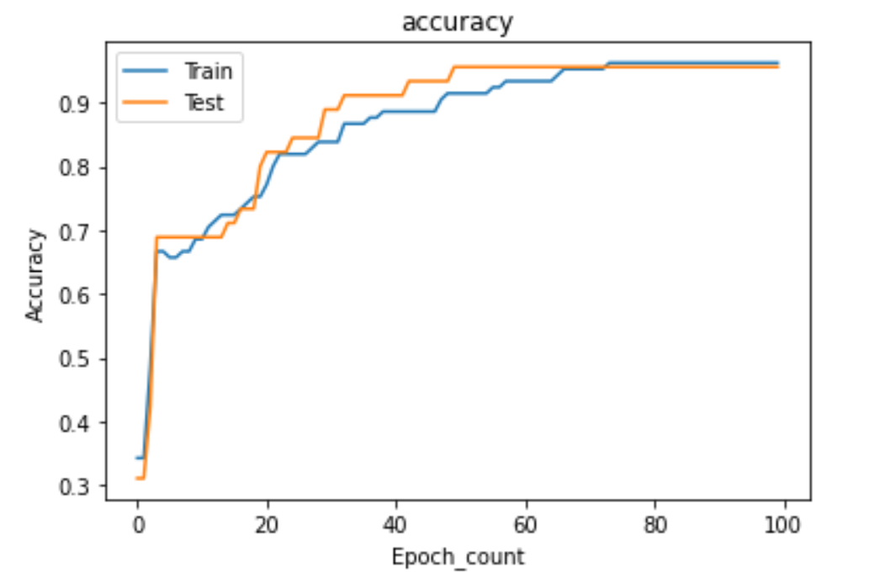

**Mean Square Error**

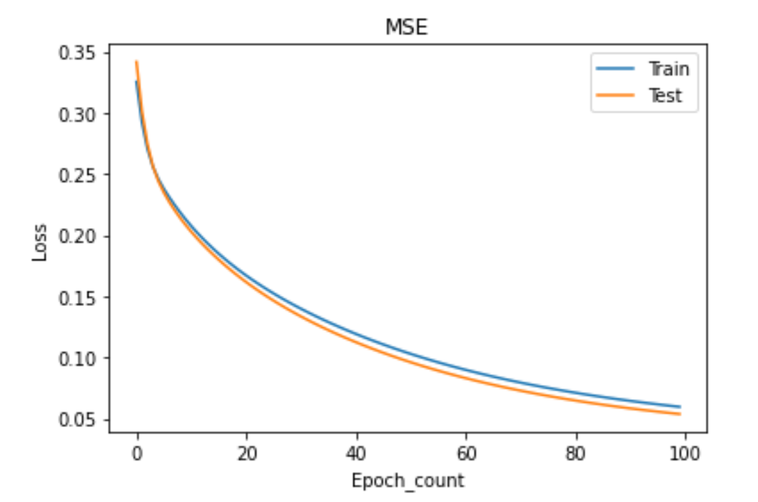

**Cross Entropy**

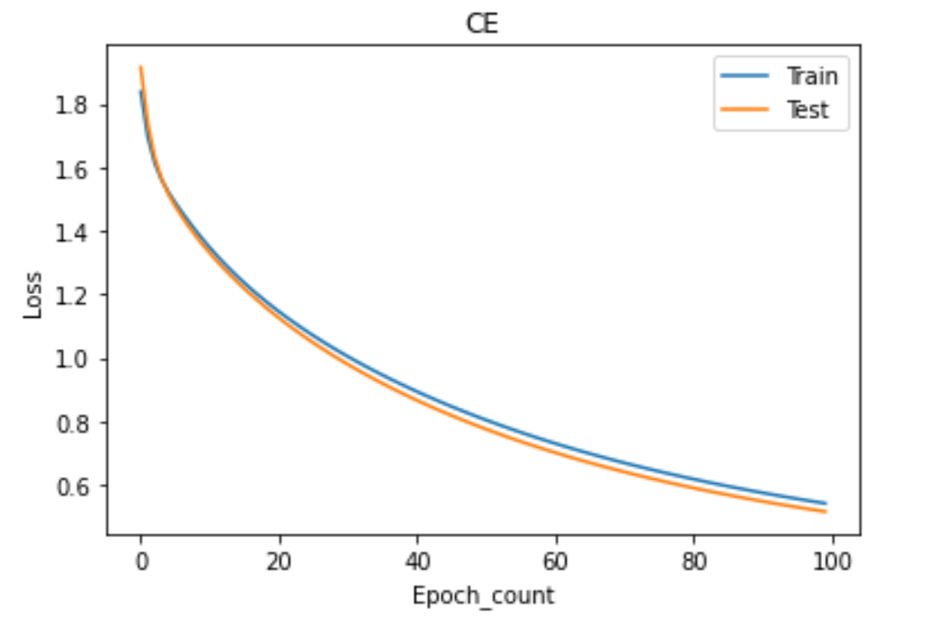

**LogLikelihood**

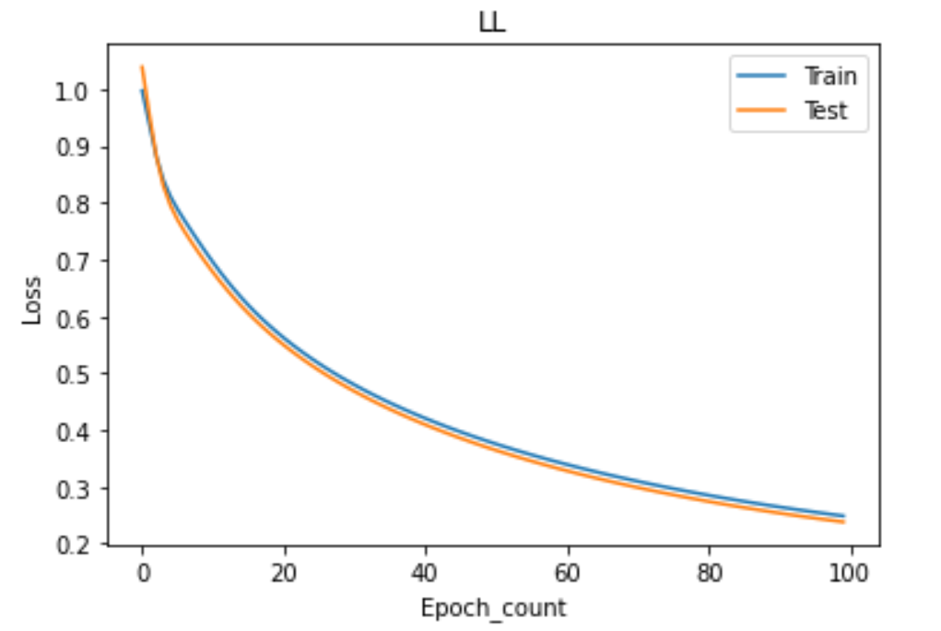

1. **Reaction and reflection**

In my point of view the difficulty level was little tough but with the data given and the link to the book helped me understand what to be done in the assignment. Editing backprop and the evaluate was easy with help of that book and from lecture. Editing SGD was tough for me like it took me a long time to do it. Visualizing those things were not as hard I thought would be. I just have to use the appropriate functions in python.